CDAC Mumbai

Lab Assignment: Flowchart and Java Programming

# Instructions:

1. For each of the following questions, first **create a flowchart** to outline the logic.
2. After completing the flowchart, **write a Java program** to implement the logic based on your flowchart.
3. Ensure your code follows basic Java syntax and logic.
4. You can explore user input (NOT MANDATORY)

# Flowchart + Java Program Questions

1. **Check Positive Number:**
   * **Task**: Create a flowchart to check whether a number is positive.

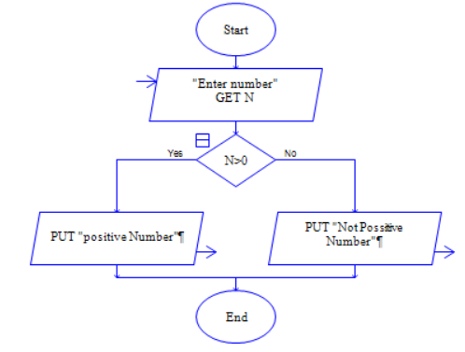

* + **Next Step**: Write a Java program that checks if a predefined number is positive using an if-else statement and prints the appropriate message.

**Program code:**

**import java.util.*;**

**public class Positivenumber{**

**public static void main(String[] args){**

**System.out.println("Enter a number: ");**

**Scanner sc = new Scanner(System.in);**

**int n = sc.nextInt();**

**if(n>0){**

**System.out.println("The given number is positive");**

**}**

**else{**

**System.out.println("the given number is negative");**

**}**

**}**

**}**

# Check Negative Number:

* + **Task**: Create a flowchart to check whether a number is negative.

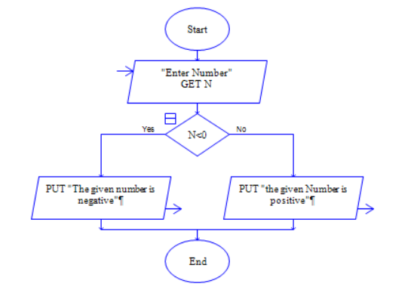

* + **Next Step**: Write a Java program that checks if a predefined number is negative using an if-else statement and displays the result.

**Program code:**

**import java.util.*;**

**public class Positivenumber{**

**public static void main(String[] args){**

**System.out.println("Enter a number: ");**

**Scanner sc = new Scanner(System.in);**

**int n = sc.nextInt();**

**if(n<0){**

**System.out.println("The given number is negative");**

**}**

**else{**

**System.out.println("the given number is positive");**

**}**

**}**

**}**

# Check Odd or Even Number:

* + **Task**: Create a flowchart to determine whether a number is odd or even.

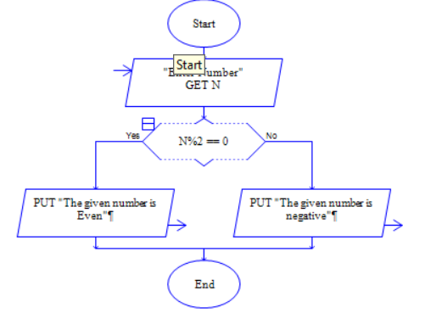

* + **Next Step**: Write a Java program that checks if a predefined number is odd or even. Use an if-else statement and the modulus operator (%) to determine whether the number is divisible by 2 or not.

**Program code:**

**import java.util.*;**

**public class EvenOdd{**

**public static void main(String[] args){**

**System.out.println("Enter a number: ");**

**Scanner sc = new Scanner(System.in);**

**int n = sc.nextInt();**

**if(n%2==0){**

**System.out.println("The given number is Even");**

**}**

**else{**

**System.out.println("the given number is Odd");**

**}**

**}**

**}**

# Display Good Morning Message Based on Time:

* + **Task**: Create a flowchart to display a "Good Morning" message based on a given time.

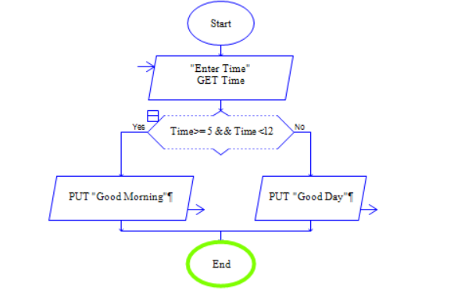

* + **Next Step**: Write a Java program that displays a "Good Morning" message if the predefined time is between 5 AM and 12 PM. Use an if statement to implement the logic.

**Program code:**

**import java.util.*;**

**public class Goodmorning{**

**public static void main(String[] args){**

**System.out.println("Enter a time in hours: ");**

**Scanner sc = new Scanner(System.in);**

**int n = sc.nextInt();**

**if(n>=5 && n<12){**

**System.out.println("Good Morning");**

**}**

**else{**

**System.out.println("Good Day");**

**}**

**}**

**}**

# Print Area of a Square:

* + **Task**: Create a flowchart to calculate and print the area of a square.

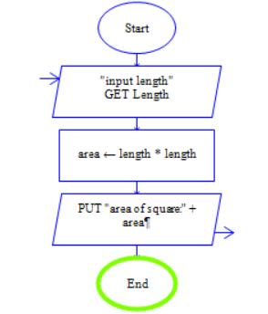

* + **Next Step**: Write a Java program that calculates the area of a square using the formula area = side * side. Use a predefined side length.

**Program code:**

**import java.util.Scanner;**

**public class SquareArea {**

**public static void main(String[] args) {**

**System.out.println("Enter the length of the side of the square:");**

**Scanner sc = new Scanner(System.in);**

**int side = sc.nextInt();**

**int area = side * side;**

**System.out.println("The area of the square with side length " + side + " is: " + area);**

**}**

**}**

# Print Area of a Rectangle:

* + **Task**: Create a flowchart to calculate and print the area of a rectangle.

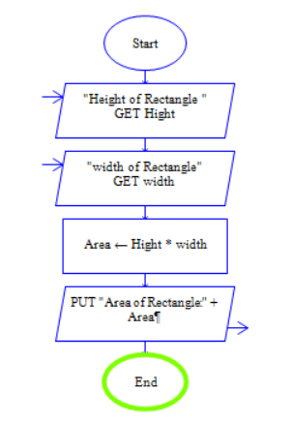

* + **Next Step**: Write a Java program that calculates the area of a rectangle using the formula area = length * width. Use predefined values for length and width.
  + **Program code:**

**import java.util.*;**

**public class Areaofrectangle{**

**public static void main(String[] args) {**

**Scanner Sc = new Scanner(System.in);**

**System.out.println("Enter the Height of Rectangle :");**

**int Height = Sc.nextInt();**

**System.out.println("Enter the Width of Rectangle :");**

**int Width = Sc.nextInt();**

**int area = Height * Width;**

**System.out.println("The area of Rectangle is: " + area);**

**}**

**}**

# Find the Largest of Three Numbers:

* + **Task**: Create a flowchart to find the largest of three numbers.

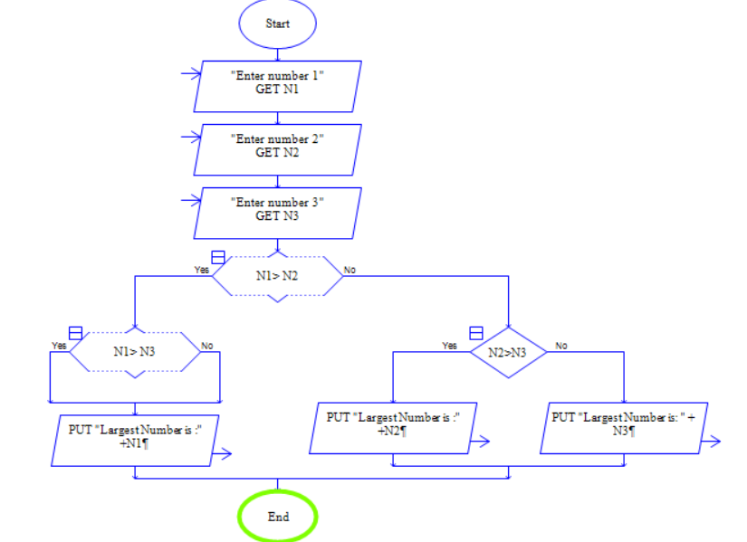

* + **Next Step**: Write a Java program that finds and prints the largest of three predefined numbers using if-else statements.
  + **Program code:**

**import java.util.*;**

**public class Positivenumber{**

**public static void main(String[] args){**

**System.out.println("Enter a number: ");**

**Scanner sc = new Scanner(System.in);**

**int n = sc.nextInt();**

**if(n>0){**

**System.out.println("The given number is positive");**

**}**

**else{**

**System.out.println("the given number is negative");**

**}**

**}**

**}**